You’re Invited To Participate

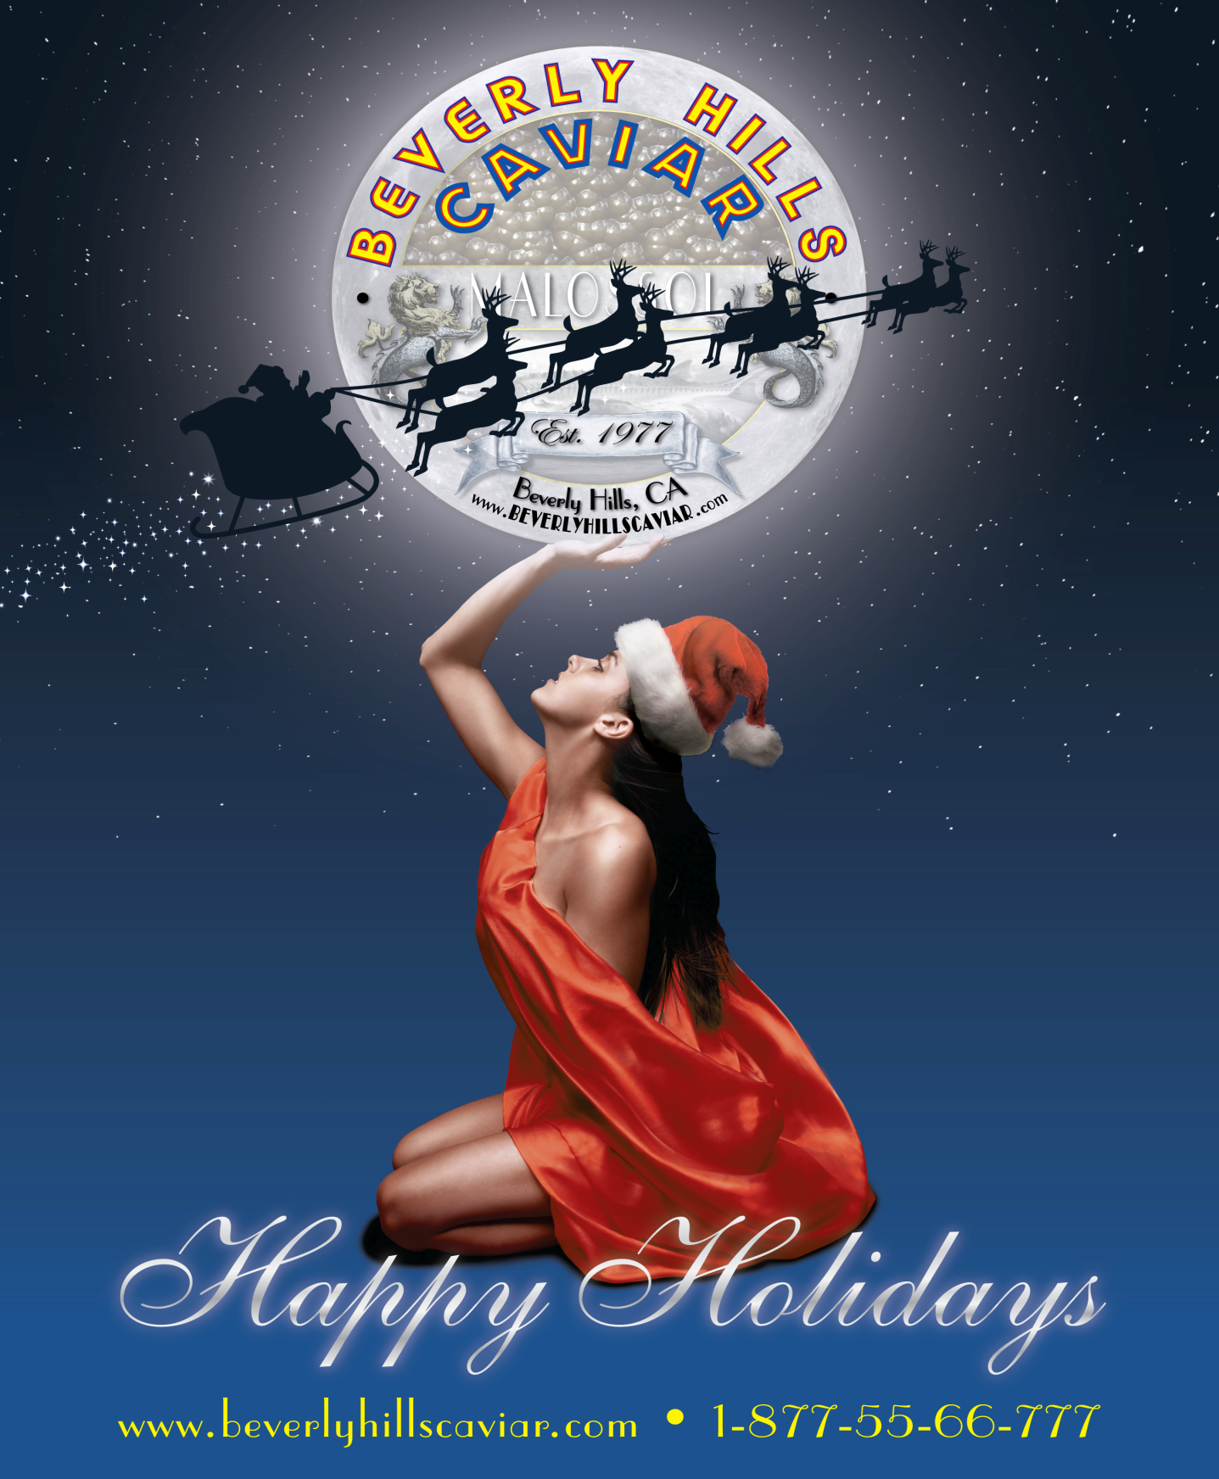
Your Last Chance To Promote Your Business Before The Upcoming Holiday Season!

The Beverly Hills Caviar Tasting Club
Charity Event is held in a top-of-a-cliff Bel Air Mansion

Tuesday, November 15th, 2011 at 6PM

http://www.beverlyhillscaviar.com/productplacement/luxuryeventchefmarcelvigneron/

Sponsorship Packages

Classic Sponsorship - $500
- Display table
- Two vendor badges
- Social media cover before and after the event.
- Opportunity to promote products in the event gift bags

Royal Sponsorship - $1,000
- Display table
- Two vendor badges
- Social media cover before and after the event.
- Opportunity to promote products/services in the gift bags
- Opportunity to promote products/services in the VIP gift bag (only special guests will be receiving).
- Digital copy of all the pictures at the event.

Imperial Sponsorship - $2,000
- Display table
- Two vendor badges
- Media and social media cover before and after the event.
- Opportunity to promote products/services in the gift bags
- Opportunity to promote products/services in the VIP gift bag (only special guests will be receiving).
- Digital copy of all the pictures at the event.
- Logo will be on the Media Wall.
- Facilitated Pictures with celebrity guests next to the vendor display area and Media Wall.

Celebrity Sponsorship - $5,000 – Only four spots available
- Large exhibitor area in the center of the room.
- Two vendor badges.
- Two guest tickets.
- Media and social media cover before and after the event.
- Opportunity to promote products/services in the gift bags
- Opportunity to promote products/services in the VIP gift bag (only special guests will be receiving).
- Digital copy of all the pictures at the event.
- Logo will be displayed four times on the Media wall.
- Picture with celebrity guest next to the vendor display area.

Celebrity Sponsorship - $10,000 – Only four spots available
- Large exhibitor area in the center of the room.
- Two vendor badges.
- Two guest tickets.
- Media and social media cover before and after the event.
- Opportunity to promote products/services in the gift bags
- Opportunity to promote products/services in the VIP gift bag (only special guests will be receiving).
- Digital copy of all the pictures at the event.
- Logo will be displayed four times on the Media wall.
- Picture with celebrity guest next to the vendor display area.
- Our Celebrity Host will announce your company to the guests.
- Private Interview for your company and a video copy for you to use on Youtube.com and promote your company to the world.

Celebrity Sponsorship - $18,000 – Only four spots available
- Large exhibitor area in the center of the room.
- Two vendor badges.
- Two guest tickets.
- Media and social media cover before and after the event.
- Opportunity to promote products/services in the gift bags
- Opportunity to promote products/services in the VIP gift bag (only special guests will be receiving).
- Digital copy of all the pictures at the event.
- Logo will be displayed four times on the Media wall.
- Picture with celebrity guest next to the vendor display area.
- Our Celebrity Host will announce your company to the guests.
- Private Interview for your company and a video copy for you to use on Youtube.com and promote your company to the world.
- Your own Private celebrity MC to promote your product and a video documentation of the entire event from your perspective.
EXHIBITOR CONTRACT

Please make the check payable to:
Beverly Hills Caviar Company
468 N Camden Drive #303
Beverly Hills, CA 90210

Sponsorship Level: _________________________________
Company name: ____________________________________
Name: ________________________Title:______________
Street address: _____________________________________
City: ______________________ State: ____ Zip: _________
Telephone: _________________________
Email: ____________________________________________
Menu Items (apply to food and wine vendors only): ________
_________________________________________________
_________________________________________________
Date: ____________
Signature: ____________________

Gift bags will be given to any guest and press/media representative that will be attending the event. Exclusive VIP gift bags will be given ONLY to press/media representatives who will cover the event and special VIP guests. If you are interested in promoting any items in the VIP gift bags you will be receiving the final count of special guest few days prior to the event.
Beverly Hills Caviar Charity Event’s gift bags will be in use for the participating vendors to promote their products and services. Vendors can giveany gift that will best represent their company (products, samples, brochures, or gift cards).
Service Fees: Non-refundable

This form is a binding contract between Beverly Hills Caviar and exhibitor.We have read the rules and regulations and we agree to pay a non-refundable sponsorship fee according to the sponsorship description above. We agree to abide by all instructions, exhibitor information and the rules and regulations, which are a part of this agreement. We agreed to accept the space assign by the event manager and that will be judged upon the best interest of the event. Any space that is not fully paid may be offered to other exhibitor.

Photographs and videos are not allowed to be taken by any guest or vendor at the mansion. Only Media and Beverly Hills Caviar's crew will be documenting the event. All photos will be released to exhibitors after the event. Photos will also be available to Facebook Friends of Beverly Hills Caviar.

The event is part of the Beverly Hills Tasting Club Experience.

Dress code: Formal. Black Tie Event.

